

# 

### Semester One Examination, 2017

### Question/Answer booklet

# MATHEMATICS

**SOLUTIONS**

**APPLICATIONS**

**UNIT 1**

## Section Two:

## Calculator-assumed

|  |  |  |  |  |  |  |  |  |  |  |
| --- | --- | --- | --- | --- | --- | --- | --- | --- | --- | --- |
| Student Number: In figures |  |  |  |  |  |  |  |  |  |  |

In words

Your name

## Time allowed for this section

Reading time before commencing work: ten minutes

Working time: one hundred minutes

## Materials required/recommended for this section

***To be provided by the supervisor***

This Question/Answer booklet

Formula sheet (retained from Section One)

***To be provided by the candidate***

Standard items: pens (blue/black preferred), pencils (including coloured), sharpener, correction fluid/tape, eraser, ruler, highlighters

Special items: drawing instruments, templates, notes on two unfolded sheets of A4 paper, and up to three calculators approved for use in this examination

## Important note to candidates

No other items may be taken into the examination room. It is **your** responsibility to ensure that you do not have any unauthorised material. If you have any unauthorised material with you, hand it to the supervisor **before** reading any further.

## Structure of this paper

|  |  |  |  |  |  |
| --- | --- | --- | --- | --- | --- |
| Section | Number of questions available | Number of questions to be answered | Working  time (minutes) | Marks available | Percentage of examination |
| Section One:  Calculator-free | 7 | 7 | 50 | 51 | 35 |
| Section Two:  Calculator-assumed | 14 | 14 | 100 | 100 | 65 |
|  | | |  | **Total** | 100 |

## Instructions to candidates

1. The rules for the conduct of examinations are detailed in the school handbook. Sitting this examination implies that you agree to abide by these rules.

2. Write your answers in this Question/Answer booklet.

3. You must be careful to confine your response to the specific question asked and to follow any instructions that are specified to a particular question.

4. Additional working space pages at the end of this Question/Answer booklet are for planning or continuing an answer. If you use these pages, indicate at the original answer, the page number it is planned/continued on and write the question number being planned/continued on the additional working space page.

5. Show all your working clearly. Your working should be in sufficient detail to allow your answers to be checked readily and for marks to be awarded for reasoning. Incorrect answers given without supporting reasoning cannot be allocated any marks. For any question or part question worth more than two marks, valid working or justification is required to receive full marks. If you repeat any question, ensure that you cancel the answer you do not wish to have marked.

6. It is recommended that you do not use pencil, except in diagrams.

7. The Formula sheet is not to be handed in with your Question/Answer booklet.

Section Two: Calculator-assumed 65% (100 Marks)

This section has**fourteen (****14)** questions. Answer **all** questions. Write your answers in the spaces provided.

Working time: 100 minutes.

Question 8 (4 marks)

An aunt plans to deposit $7 500 into a savings account for five years, so that when her nephew turns 17 she can help him buy a car.

Her bank has two accounts that she is considering: a 'Basic' savings account that is offering simple interest of 4.2% per annum; and a 'Builder' savings account that is offering an interest rate of 3.9% per annum, compounded annually.

State, with justification, which account you would recommend the aunt uses.

|  |
| --- |
| **Solution** |
| Aunt should choose Builder, as she will end up with $6.11 more after five years. |
| **Specific behaviours** |
| ✓ calculates simple interest  ✓ calculates future value after compounding  ✓ calculates interest or future value for both  ✓ makes recommendation with reason |

Question 9 (7 marks)

The diagram below shows the dimensions of a paved area (shaded) that is adjacent to a circular pool of radius 4 m.

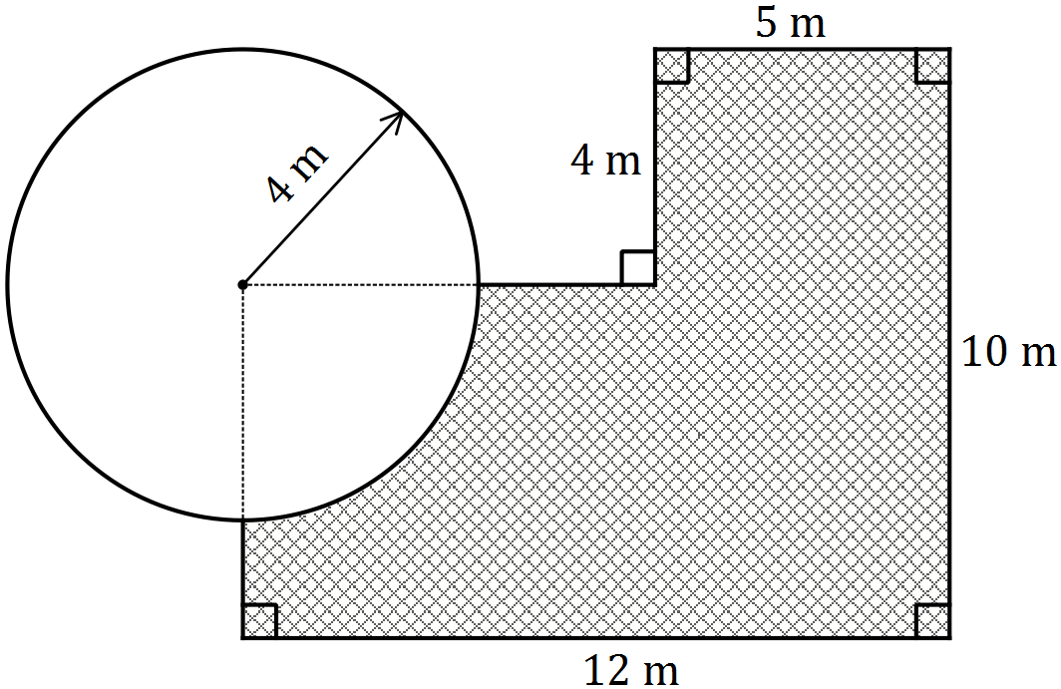

(a) Determine the length of the perimeter of the paved area. (3 marks)

|  |
| --- |
| **Solution** |
| Missing lengths: and  Quadrant:  Perimeter: |
| **Specific behaviours** |
| ✓ determines missing lengths  ✓ determines quadrant length  ✓ determines perimeter |

(b) Determine the area of the paving. (4 marks)

|  |
| --- |
| **Solution** |
| Rectangles:  Quadrant:  Area: |
| **Specific behaviours** |
| ✓ splits into composite rectangles  ✓ calculates area of rectangles  ✓ calculates area of quadrant  ✓ calculates area of surface |

Question 10 (6 marks)

A tradesman uses the spreadsheet below to quote customers the price of a job ($), depending on the number of days the job will take () and how many labourers () will be required. The prices all include GST at 10%.

The formula used in the spreadsheet is .

|  |  |  |  |  |  |
| --- | --- | --- | --- | --- | --- |
| Job prices ($) | | Length of job in days () | | | |
| 1 | 2 | 3 | 4 |
| Number of labourers () | 1 | 455 | 675 |  | 1115 |
| 2 | 540 | 760 | 980 | 1200 |
| 3 | 625 |  | 1065 | 1285 |

(a) For a job lasting four days and requiring three labourers:

(i) state the price the tradesman will quote. (1 mark)

|  |
| --- |
| **Solution** |
| $1285 |
| **Specific behaviours** |
| ✓ states price |

(ii) calculate how much GST is included in the quote. (1 mark)

|  |
| --- |
| **Solution** |
|  |
| **Specific behaviours** |
| ✓calculates GST |

(b) Determine the values of and in the spreadsheet. (2 marks)

|  |
| --- |
| **Solution** |
|  |
| **Specific behaviours** |
| ✓ value of  ✓ value of |

(c) The tradesman quoted a price of $1 895 for a job lasting 6 days. Determine the number of labourers required for this job. (2 marks)

|  |
| --- |
| **Solution** |
|  |
| **Specific behaviours** |
| ✓ substitutes  ✓ states number of labourers |

Question 11 (9 marks)

The Disability Support Pension payments per fortnight for qualifying persons under 21 years of age who are single with no children are shown in the table below.

|  |  |
| --- | --- |
| Status | Payment |
| Single, under 18 years of age, at home | $364.20 |
| Single, under 18 years of age, independent | $562.20 |
| Single, 18-20 years of age, at home | $412.80 |
| Single, 18-20 years of age, independent | $562.20 |

Persons who receive this pension can earn up to $164 fortnightly with no reduction in payment. Earnings over this figure will reduce the payment by 50 cents for each dollar over $164.

(a) A 19-year-old person who lives at home qualifies for this pension and has a part time job for 24 hours per fortnight that pays $16.50 per hour.

(i) Calculate the fortnightly earnings from their job. (1 mark)

|  |
| --- |
| **Solution** |
| Earnings are |
| **Specific behaviours** |
| ✓ calculates earnings |

(ii) Determine by how much, if at all, their fortnightly pension will be reduced. (2 marks)

|  |
| --- |
| **Solution** |
| Exceed $164 by . reduction |
| **Specific behaviours** |
| ✓ calculates amount exceeding $164  ✓ calculates reduction |

(iii) Determine the fortnightly sum of earnings and pension for this person. (2 marks)

|  |
| --- |
| **Solution** |
| Payment is $412.80  Sum is |
| **Specific behaviours** |
| ✓ selects correct pension rate  ✓ calculates sum |

(b) An 18-year-old person who lives independently qualifies for this pension and is also paid $17.75 an hour for 20 hours work each week. Determine the fortnightly sum of earnings and pension for this person. (4 marks)

|  |
| --- |
| **Solution** |
| Fortnightly pension:  Fortnightly earnings:  Deduction:  Sum: |
| **Specific behaviours** |
| ✓ correct pension rate  ✓ correct fortnightly earnings  ✓ correct deduction  ✓ correct net sum |

Question 12 (8 marks)

A playground has the shape of quadrilateral shown below, where the lengths of , and are 36 m, 77 m and 13 m respectively. Angles and are both .

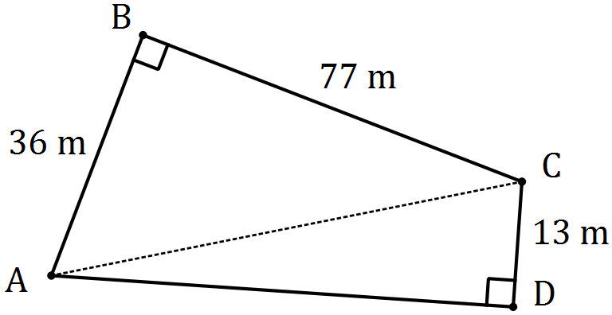

(a) Determine the lengths of

(i) diagonal . (2 marks)

|  |
| --- |
| **Solution** |
|  |
| **Specific behaviours** |
| ✓ uses Pythagoras' theorem  ✓ determines length |

(ii) side . (2 marks)

|  |
| --- |
| **Solution** |
|  |
| **Specific behaviours** |
| ✓ uses Pythagoras' theorem  ✓ determines length |

A square playground has the same area as the playground .

(b) Determine the area of playground . (2 marks)

|  |
| --- |
| **Solution** |
|  |
| **Specific behaviours** |
| ✓ calculates areas of right triangles  ✓ calculates total area |

(c) Determine the perimeter of the square playground . (2 marks)

|  |
| --- |
| **Solution** |
|  |
| **Specific behaviours** |
| ✓ determines side of square  ✓ calculates perimeter (any value that rounds to 176) |

Question 13 (6 marks)

The depth of water in a rectangular swimming pool increases steadily from 75 cm at the shallow end to 185 cm at the deep end. The pool has vertical walls and is 4.4 m wide and 8.5 m long.

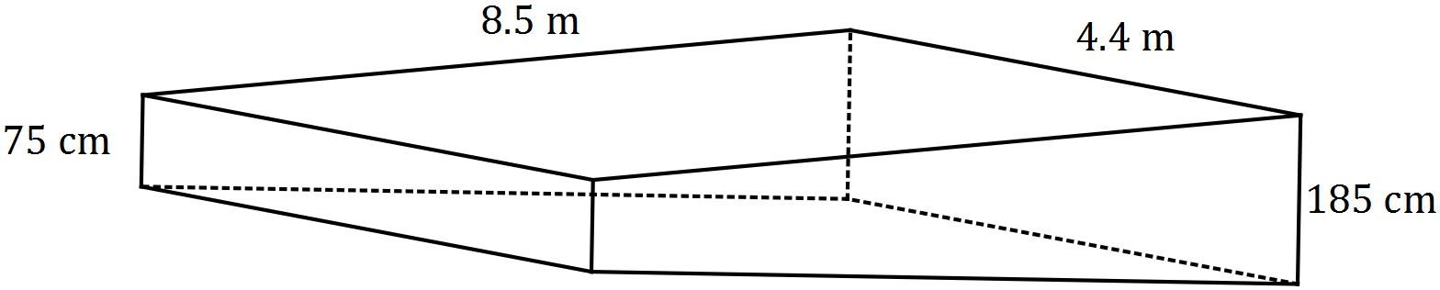

(a) A blanket to cover the water surface is to be made from material costing $6.60 per square metre. Determine the cost of material for the blanket. (2 marks)

|  |
| --- |
| **Solution** |
|  |
| **Specific behaviours** |
| ✓ calculates surface area  ✓ calculates cost |

(b) Determine the capacity, in kilolitres, of water in the pool. (4 marks)

|  |
| --- |
| **Solution** |
|  |
| **Specific behaviours** |
| ✓ uses trapezoidal cross-section  ✓ converts all units to either cm or m  ✓ calculates cross-sectional area  ✓ calculates capacity, stating units |

Question 14 (9 marks)

The table below shows the budget used by a young person for running their medium-sized car last year.

|  |  |
| --- | --- |
| Item | Average Weekly Amount |
| Depreciation | $72.50 |
| Loan Repayment | $55.25 |
| Registration | $7.75 |
| Insurance | $23.40 |
| Fuel | $18.30 |
| Tyres | $2.65 |
| Servicing | $21.90 |

(a) Determine the

(i) weekly total of these amounts. (1 mark)

|  |
| --- |
| **Solution** |
| Total is $201.75 |
| **Specific behaviours** |
| ✓ sums amounts |

(ii) the average **monthly** amount required to run the car, assuming there were exactly 52 weeks last year. (2 marks)

|  |
| --- |
| **Solution** |
|  |
| **Specific behaviours** |
| ✓ converts to annual amount  ✓ converts to monthly amount |

For this year, the young person expects the average weekly amount for depreciation to fall by 10%, the loan repayment to remain unchanged and all other amounts to increase by 5%.

(b) Determine the new average weekly amounts for

(i) depreciation. (1 mark)

|  |
| --- |
| **Solution** |
|  |
| **Specific behaviours** |
| ✓ decreases by 10% |

(ii) insurance. (1 mark)

|  |
| --- |
| **Solution** |
|  |
| **Specific behaviours** |
| ✓ increases by 5% |

(c) Calculate the new total weekly amount required to run the car this year. (2 marks)

|  |
| --- |
| **Solution** |
| Accept $198.21 |
| **Specific behaviours** |
| ✓ uses adjusted amounts  ✓ adds correctly |

(d) Determine the percentage change in the total weekly amount to run the car from last year to this year, correct to two decimal places. (2 marks)

|  |
| --- |
| **Solution** |
| Decrease of  decrease  Accept decrease |
| **Specific behaviours** |
| ✓ indicates a decrease  ✓ states as percentage |

Question 15 (8 marks)

A useful measurement for a photographer when setting up their digital camera for a picture is the hyperfocal distance, . The photographer knows that every object at a distance greater than half of from the camera will be in focus.

In the formula above for the hyperfocal distance , is the focal length of the lens, is the aperture number and is the diameter of the circle of confusion. All measurements must be in millimetres, apart from the aperture number.

(a) Calculate when

(i) is 35 mm, is 8 and is 0.019 mm. (2 marks)

|  |
| --- |
| **Solution** |
|  |
| **Specific behaviours** |
| ✓ substitutes correctly  ✓ evaluates |

(ii) the diameter of the circle of confusion is 0.023 mm, the focal length of the lens is 135 mm and the aperture number is 5.6, giving your answer rounded to the nearest metre. (3 marks)

|  |
| --- |
| **Solution** |
|  |
| **Specific behaviours** |
| ✓ substitutes correctly  ✓ evaluates  ✓ rounds to nearest metre |

(b) A photographer is using a lens with a focal length of 35 mm and a circle of confusion of diameter 0.03 mm. What aperture number should the photographer choose from the eight available (2.8, 4, 5.6, 8, 11, 16, 22 or 32) to ensure that all objects greater than 1.3 metres from the camera are in focus? Justify your answer. (3 marks)

|  |
| --- |
| **Solution** |
|  |
| **Specific behaviours** |
| ✓ uses correct D value  ✓ substitutes correctly  ✓ solves and chooses from given values |

Question 16 (7 marks)

(a) An inflatable swimming pool full of water is punctured and slowly begins to leak. The volume of water in the swimming pool () in litres, hours after it is punctured is given by the formula

(i) What is the initial volume of water in the swimming pool? (1 mark)

|  |
| --- |
| **Solution** |
| 6000L |
| **Specific behaviours** |
| ✓ states answer |

(ii) What is the volume of water remaining in the swimming pool after 120 hours?

(1 mark)

|  |
| --- |
| **Solution** |
| 5100L |
| **Specific behaviours** |
| ✓ states answer |

(iii) How long will it take for the volume of water in the swimming pool to be half of what it was initially? (1 mark)

|  |
| --- |
| **Solution** |
| 400 hours |
| **Specific behaviours** |
| ✓ states answer |

Question 17 (4 marks)

1. A junior football club conducts a raffle. In total, 350 tickets are expected to be sold, at $3 for members and $5 for non-members. The club requires the money raised from ticket sales to cover the cost of the prize, which was $500, as well as new uniforms which cost $830.
2. Assuming the football club is to exactly achieve its goal and its expectation regarding ticket sales is correct, write an equation which can be solved to find the number of tickets sold to members. (2 marks)

|  |
| --- |
| **Solution** |
|  |
| **Specific behaviours** |
| ✓ defines as number of member tickets and identifies that number of non-member tickets is  ✓ correct equation |

(ii) State the number of tickets sold to members and the number of tickets sold to non-members. (2 marks)

|  |
| --- |
| **Solution** |
| 210 tickets sold to members  140 tickets sold to non-members |
| **Specific behaviours** |
| ✓ states number of tickets sold to members  ✓ states number of tickets sold to non-members |

Question 18 (9 marks)

A hollow plastic hemisphere of external radius 25 cm and internal radius of 23.5 cm is shown below.

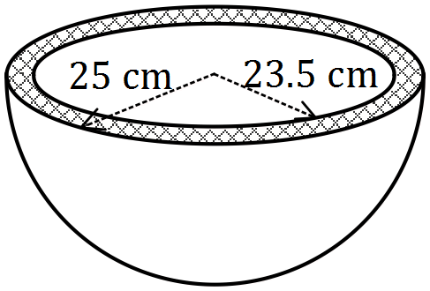

(a) Show that the internal surface area of the hemisphere is close to 3 500 cm2. (2 marks)

|  |
| --- |
| **Solution** |
|  |
| **Specific behaviours** |
| ✓ uses sphere TSA formula with  ✓ shows area to at least 3sf |

(b) Calculate the area of the circular cross-section, shaded in the diagram. (2 marks)

|  |
| --- |
| **Solution** |
|  |
| **Specific behaviours** |
| ✓ calculates inner and outer circle areas  ✓ calculates difference as 228 or 229 |

(c) Determine the volume of plastic in the hemisphere. (3 marks)

|  |
| --- |
| **Solution** |
|  |
| **Specific behaviours** |
| ✓ calculates inner volume  ✓ calculates outer volume  ✓ calculates difference |

(d) A solid cube of plastic measuring 75cm by 75cm by 75cm is to be melted and fed into a moulding machine that makes the hollow hemispheres. If there is no wastage, how many hollow hemispheres can be made? (2 marks)

|  |
| --- |
| **Solution** |
|  |
| **Specific behaviours** |
| ✓ calculates volume of plastic  ✓ calculates number of hemispheres |

Question 19 (9 marks)

The pay rates for full and part time 17-year-old hotel employees are shown in this table.

| **Hourly pay rate** | **Evening - Monday to Friday - 7pm to midnight** | **Night work - Monday to Friday - midnight to 7am** | **Saturday** | **Sunday** |
| --- | --- | --- | --- | --- |
| $10.93 | $10.93 per hour plus $2.06 per hour or part of an hour | $10.93 per hour plus $3.09 per hour or part of an hour | $13.66 | $19.13 |

Meal and other breaks taken during a working day are unpaid.

(a) Calculate the weekly wage for a 17-year-old who worked from 8 am until 3 pm from Tuesday to Saturday inclusive, taking a break from 11 am until 11.30 am each day.

(3 marks)

|  |
| --- |
| **Solution** |
| Paid hours per day:  Tue-Fri: , Sat:  Total: |
| **Specific behaviours** |
| ✓ calculates hours each day  ✓ uses correct rates for days  ✓ calculates total |

(b) A 17-year-old was asked to cover for an absent staff member from 3 pm to 11 pm one Thursday, taking a meal break from 7.15 pm to 8 pm. How much did they earn this day?

(3 marks)

|  |
| --- |
| **Solution** |
| Paid hours at $10.93:  Bonus payments after 7 pm:  Total earnings: |
| **Specific behaviours** |
| ✓ regular hours  ✓ bonus hours  ✓ total earnings |

(c) A 17-year-old earned $360.69 for working the same daily hours for five consecutive days, from Friday through to Tuesday inclusive. If they started work at 9.30 am and took a lunch break from 12.30 pm to 1.15 pm, what time did they finish work each day? (3 marks)

|  |
| --- |
| **Solution** |
| Work for 1h each day, earn  Must work  Finish work at ie at 3.45 pm |
| **Specific behaviours** |
| ✓ five-day pay rate  ✓ calculates hours per day  ✓ determines finishing time |

Question 20 (10 marks)

A triangular prism has a square base of side 36 cm, two triangular ends and two sloping rectangular faces measuring 36 cm by 30 cm, as shown in the diagram below. and are the midpoints of sides and respectively.

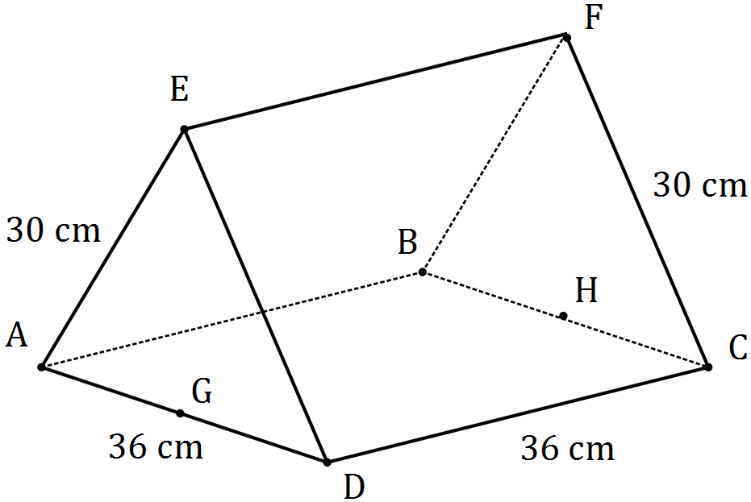

(a) Calculate the length of the diagonal in rectangle . (2 marks)

|  |
| --- |
| **Solution** |
|  |
| **Specific behaviours** |
| ✓ uses Pythagoras' theorem  ✓ calculates length |

(b) Determine the length . (2 marks)

|  |
| --- |
| **Solution** |
|  |
| **Specific behaviours** |
| ✓ uses Pythagoras' theorem, halving  ✓ calculates length |

(c) Calculate the area of triangle . (2 marks)

|  |
| --- |
| **Solution** |
|  |
| **Specific behaviours** |
| ✓ uses half base times height (or Herons rule)  ✓ calculates area |

(d) Determine the total surface area of the triangular prism. (2 marks)

|  |
| --- |
| **Solution** |
|  |
| **Specific behaviours** |
| ✓ calculates parts  ✓ calculates TSA |

(e) Calculate the volume of the triangular prism. (2 marks)

|  |
| --- |
| **Solution** |
|  |
| **Specific behaviours** |
| ✓ uses cross-section times length  ✓ calculates volume, with units |

Question 21 (8 marks)

A supermarket stocked three brands of paper towels, as shown in the table below.

|  |  |  |  |
| --- | --- | --- | --- |
| Brand name | Absorb | Blotter | Spongy |
| Price per roll | $1.95 | $2.65 | $2.50 |
| Number of sheets per roll | 160 | 220 | 200 |

(a) Use the unit cost method to

(i) calculate the price per sheet of each brand. (2 marks)

|  |
| --- |
| **Solution** |
| Absorb:  Blotter:  Spongy: |
| **Specific behaviours** |
| ✓ one correct calculation  ✓ all correct |

(ii) state which brand is cheapest per sheet and state the price per 100 sheets of this brand. (2 marks)

|  |
| --- |
| **Solution** |
| Blotter is cheapest, costing $1.20 per 100 sheets |
| **Specific behaviours** |
| ✓ chooses lowest price  ✓ states price per 100 sheets |

A consumer watchdog noticed that the size of paper sheets varied between brands, as shown in this table.

|  |  |  |  |
| --- | --- | --- | --- |
| Brand name | Absorb | Blotter | Spongy |
| Size of one sheet from roll (cm) | 2121 | 1821 | 2021 |

(b) Use the unit cost method to calculate the price per square centimetre of paper towel for each brand and comment on whether these new measures support your answer to (a)(ii).

(4 marks)

|  |
| --- |
| **Solution** |
| Absorb:  Blotter:  Spongy:  No support for previous answer, as Blotter is the most expensive and Absorb is now the cheapest using this measure. |
| **Specific behaviours** |
| ✓ calculates area of each sheet  ✓ calculates one unit price per sq cm  ✓ calculates all unit prices  ✓ makes relevant comment |

Additional working space

Question number: _________

© 2016 WA Exam Papers. Kennedy Baptist College has a non-exclusive licence to copy and communicate this paper for non-commercial, educational use within the school. No other copying, communication or use is permitted without the express written permission of WA Exam Papers. SN245-093-4.